
The Catholic Church: Seaford, Newhaven
& Peacehaven | Sunday 1st December 2024

Welcome
Welcome to our Church Community. If you are new or visiting, please do introduce yourself to Deacon Stephen who will be delighted to meet you.

Prayer
‘A prayer for life’ at this tragic time for our country. MPs have voted 330 to 275 in support of the assisted dying bill. Let us pray.
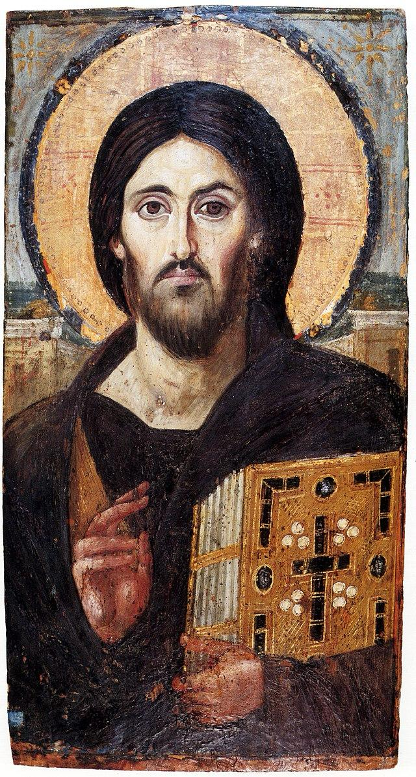
Father and maker of all, you adorn all creation with splendour and beauty, and fashion human lives in your image and likeness. Awaken in every heart reverence for the work of your hands, and renew among your people a readiness to nurture and sustain your precious gift of life. Grant this through our Lord Jesus Christ, your Son,
who lives and reigns with you
in the unity of the Holy Spirit,
God forever and ever. Amen

Formation
Advent Courses:
- Thursday Mornings at 11am in Seaford after Holy Mass.
- Saturday Mornings at 10am in Peacehaven.

Mission
Patronal Feast Day of the Immaculate Conception of Our Lady is on Monday 9th December. We will celebrate with Holy Mass at 10am followed by tea/coffee and cake. We will continue to celebrate and look forward to Christmas with mulled wine in Peacehaven at 7.30pm, please bring some nibbles to share! This event is for everyone from both our church communities, see you there.

Thank you to everyone who helped with and supported the Autumn Fair, raising funds for Madagascar.

Other Stuff
New missals have arrived!
Repository sale of Christmas items Sunday, 8th December after the 11 am Mass, Seaford Church Hall.

Christmas Services:
Christmas Vigil 6pm -Seaford
Christmas Vigil 6pm - Peacehaven
Christmas Day 9 am - Peacehaven
Christmas Day 11 am – Seaford
New Year Day 10 am - Peacehaven

1st Sunday of Advent – Year C
Liturgy Schedule for the coming week:
Holy Mass | Confession is available 30 minutes before Holy Mass
First Sunday of Advent
- Sat 30th Nov (Vigil)| 6pm|Seaford | Int: Joseph& Pauline Camilleri RIP
- Sun 1st Dec |11 am | Peacehaven | Int: People of the Parish
Midweek
- Wed 4th Dec |10 am| Peacehaven| Int: Nora Ross RIP
- Thurs 5th Dec |10am| Seaford | Int: Mike Kearon and Sister Ann RIP
Second Sunday of Advent
- Sat 7th Dec (Vigil)| 6pm|Peacehaven | Int: David Difford RIP
- Sun 8th Dec |11 am |Seafrod| Int: People of the Parish
Morning Prayer:
- Seaford: Mon – Fri 8.30am, Sat & Sun 9am | Peacehaven: Tues 9am
Evening Prayer:
- Seaford: Mon – Fri 6:30pm | Peacehaven Tue & Wed 6pm
Adoration:
- Seaford: Tue 10am (Priest vocations).
- Peacehaven: Mon 6pm (Vocations), Thur 6pm (Pastoral Plan), Fri 10am
Rosary:
- Seaford: Sat 9:15am, Thur 9:30am | Peacehaven: Wed 9.30am, Fri 9.30am
Benediction:
- Sunday 6pm | Seaford
Mass Intentions envelopes are in the porch – minimum 20 weeks’ notice.
Dates for your Diary
- 5th Dec, 11am | Advent Course: Catholic Talk Show| Seaford
- 7th Dec, 10am | Advent Course: Session 2 | Peacehaven
- 8th Dec, 3pm | Ashdown Singers Christmas Concert in aid of HomeLink | Seaford
- 9th Dec, 10am | Feast of the Immaculate Conception | Mass | Peacehaven
- 9th Dec 7.30pm | Parish Christmas Bash | Peacehaven
- 14th Dec, 12 noon | Big Church Clean | Seaford
- 11th Jan, 9.30 am | Gentlemen Who Scoff - Breakfast| Peacehaven

Mass Attendance: 281 Offertory: £160.81 and Arundel Cathedral £84.79 Peacehaven & Seaford £397.82
Second collection next week: Christmas Church Flowers

